**Project #2 NR 400 – Spring 2025**

**Developing an Outreach and Engagement Product for Spring Creek Gardens**

Group Member Names: Rachel Delorie, Nina Lewin, Tori Auger

Purpose, Behavior Change, and Action Step

The overall purpose of our event is to encourage bird conservation by increasing community knowledge of threats facing birds and ways to combat them. Within this larger goal, our specific target behavior change is for **20% of attendees to implement one bird conservation technique in their homes**. Easy at-home bird conservation techniques we provided information on included window stickers, decreasing light pollution, avoiding rodenticides and other poisons, using bird-friendly outdoor decor, and keeping cats indoors. Having 20% of participating households begin implementing any one of these bird conservation techniques would fulfill our target behavior change. This behavior is important to Spring Creek Gardens’ mission of fostering environmental stewardship and sustainability because it will help participants value and protect the animals and nature around them through education and achievable guidance on implementing bird conservation. Additionally, one of Spring Creek Gardens’ values is “honoring our local place, both the natural and human environments,” which our program achieves by teaching people to identify and care for several local bird varieties, bridging the natural and human environments by making the human spaces more habitable for other members of the natural community.

Target Audience

Our target audience for the “Birds N’ Booze” event are Northern Colorado residents, ages 21-40 who already have an interest in birding, environmental issues, or conservation. In week three NR400 content, Jones et al. says that clustering the audience based on common attributes improves marketing for an intervention in behavior, because it allows the message to be tailored to their pre-existing beliefs (Jones et al). All of these factors culminate in a homogeneous audience that is most likely to enact our desired behavior change due to their interest in birding, age range, and shared environmental values. The target age range for the audience, millennials, was chosen intentionally. Typically, millennials have the socio-economic ability and willingness to implement some of the at-home conservation actions we presented. In fact, the Deloitte Global 2022 Gen Z and Millennial survey showed that three quarters of millennials feel like more actions need to be taken to combat climate change, and that “nine in ten make an effort to protect the environment” (The Deloitte Global 2022 Gen Z and Millennial Survey). Additional research suggests that millennials are more motivated by social connection and shared experiences than other age groups. The National Public Health Initiative says, “the Millennial focus on socializing creates a demand for events that bring everyone together through novel shared experiences”. This aligns well with the social and interactive nature of the *Birds N’ Booze* event which includes live music, social hour, drinking, and participatory learning through activities such as bird bingo.

Outreach and Communication Products

Our project was creating a bird conservation educational event for the target audience of 21 to 40 year olds in Fort Collins, Colorado. The proposed itinerary for this event is as follows:

**4:30–5:00 PM — Event Setup**

* Odell Brewing Company arrives and sets up beverage service
* Gardens on Spring Creek staff set up silent auction
* Live band arrive and set up
* Final walk through before doors open

**5:15–5:30 PM — Guest Arrival & Welcome**

* Doors open to guests
* Odell brewing company beverage service begins
* Guests invited to explore the gardens at their leisure
* Bird Bingo activity opens
* **Staff note:** a staff member needs to be near the entry to welcome guests and direct them to Bird Bingo, beverages, and areas of the gardens

**5:30–6:00 PM — Bird Bingo Activity**

* Interactive Bird Bingo activity runs throughout the gardens
  + **Staff Note:** have designated staff available for assistance and engagement with this activity

**6:00–6:15 PM — Transition Period**

* Bird Bingo concludes
* Rocky Mountain Raptor Program (RMRP) sets up animal ambassadors
* Guests encouraged to settle near presentation area

**6:15–7:00 PM – RMRP Presentation**

* Educational presentation featuring live raptor ambassadors

**7:00–7:15 PM – Q&A & Wrap-Up Announcements**

* Audience Q&A with RMRP presenters
* Silent auction winners announced
* Event wrap-up, thank-you remarks, hand out at-home conservation flyers

There are two products associated with this event. First is a bird bingo card that will be used during the event. The bingo card has photos and common names of local bird species that participants are likely to see while walking around the gardens. On the back is a list of free bird identification resources. Our second product is a handout on at-home bird conservation. This handout includes five different bird conservation techniques, a link to our survey, a hashtag for participants to share their conservation measures on social media with, and potentially some items from stakeholders. Feedback received during the peer review session primarily related to our overall event concept. From this feedback, we changed the name of our event from “Bird n Wine” to “Birds N’ Booze”, a title with catchy alliteration. Additionally, peer feedback was helpful in formulating our best practices and JEDIA+ techniques.

**All Feedback**

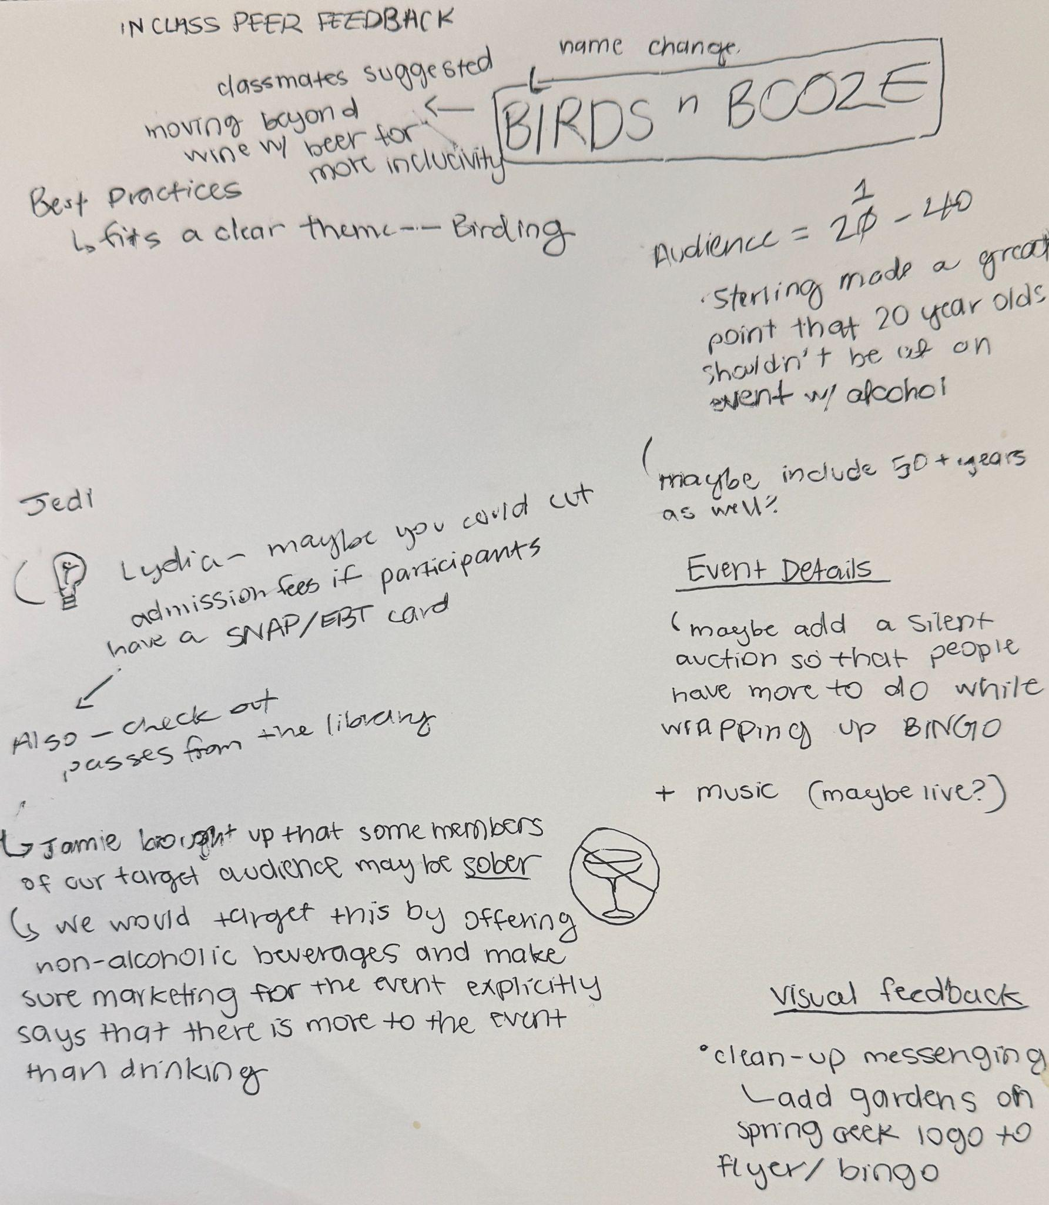

**Draft: Bird Conservation Handout**

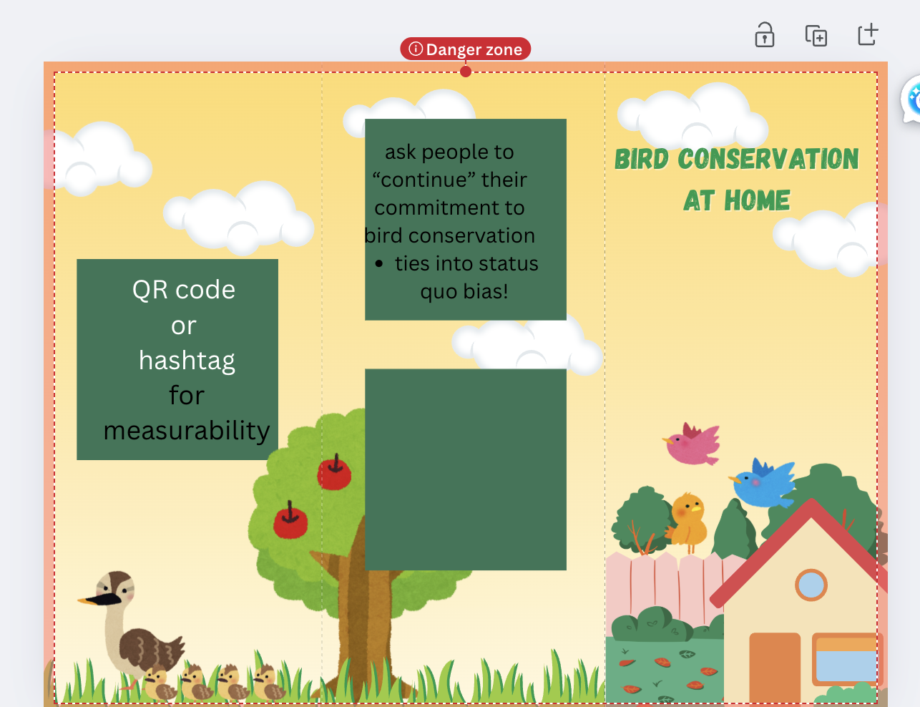

**Feedback and Feedback Implementation:** Going into the peer feedback session, the handout was our least developed deliverable at the time. We had an idea of what we wanted the handout to be, and the purpose it would serve. The handout serves as a way for our conservation goals to extend beyond the event, through accessible at home conservation practices. Our classmates suggested some visual changes we could make to the handout to better suit our target audience of 21 to 40 year olds. Our first draft handout was too playful and did not suit our project needs. It was restyled to reflect our audience using elements of the Spring Creek Garden brand design kit, such as purple and green accent colors and the company logo. The draft handout was in trifold format, but it was hard to fit all of the information we needed onto it. This resulted in our final draft handout being in a standard flyer format.

**Final Bird Conservation Handout**

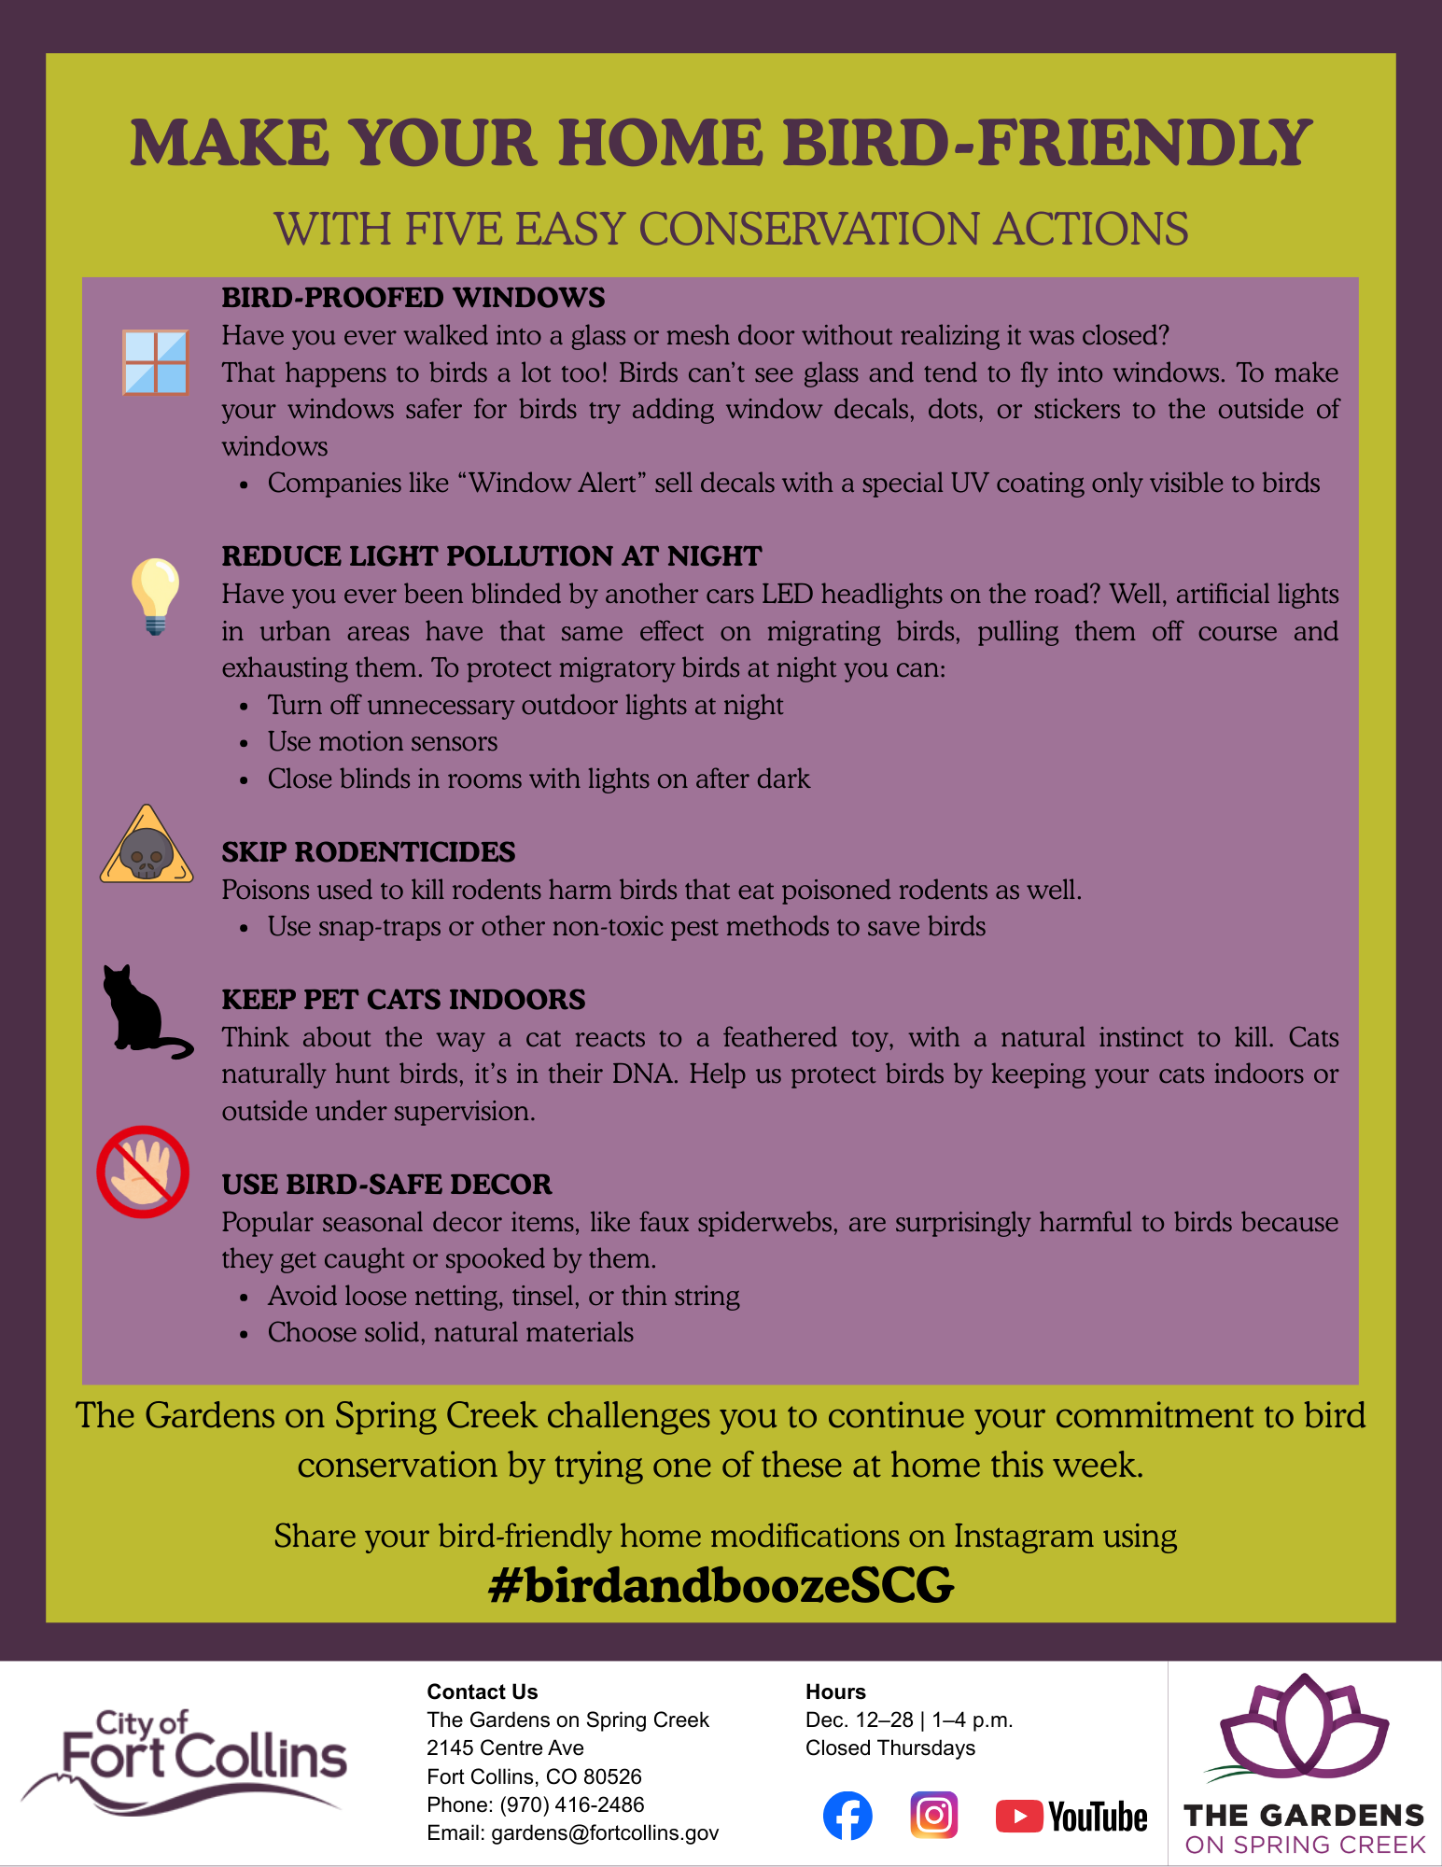

**Draft: Bird Bingo**

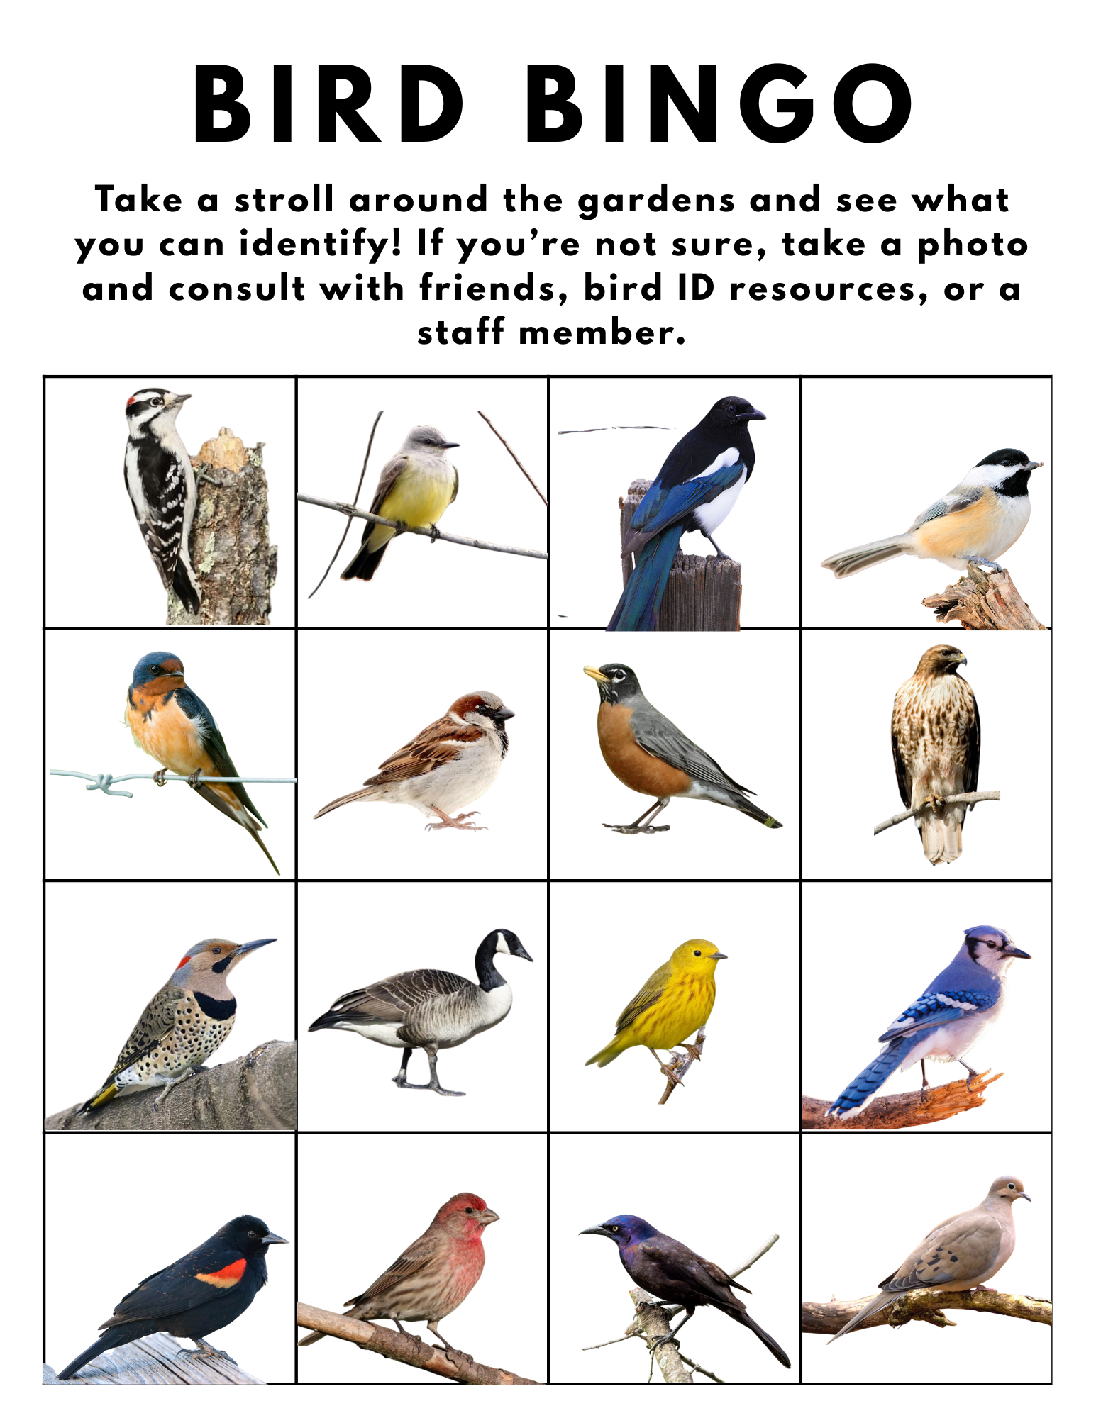

**Feedback and Feedback Implementation:**

Peer feedback during recitation was very positive for this deliverable, and many of our classmates felt like this activity was fun and engaging for our event participants. Internal feedback between group members resulted in the addition of species common names and identification resources on the back side of the bingo card.

**Final Bird Bingo**

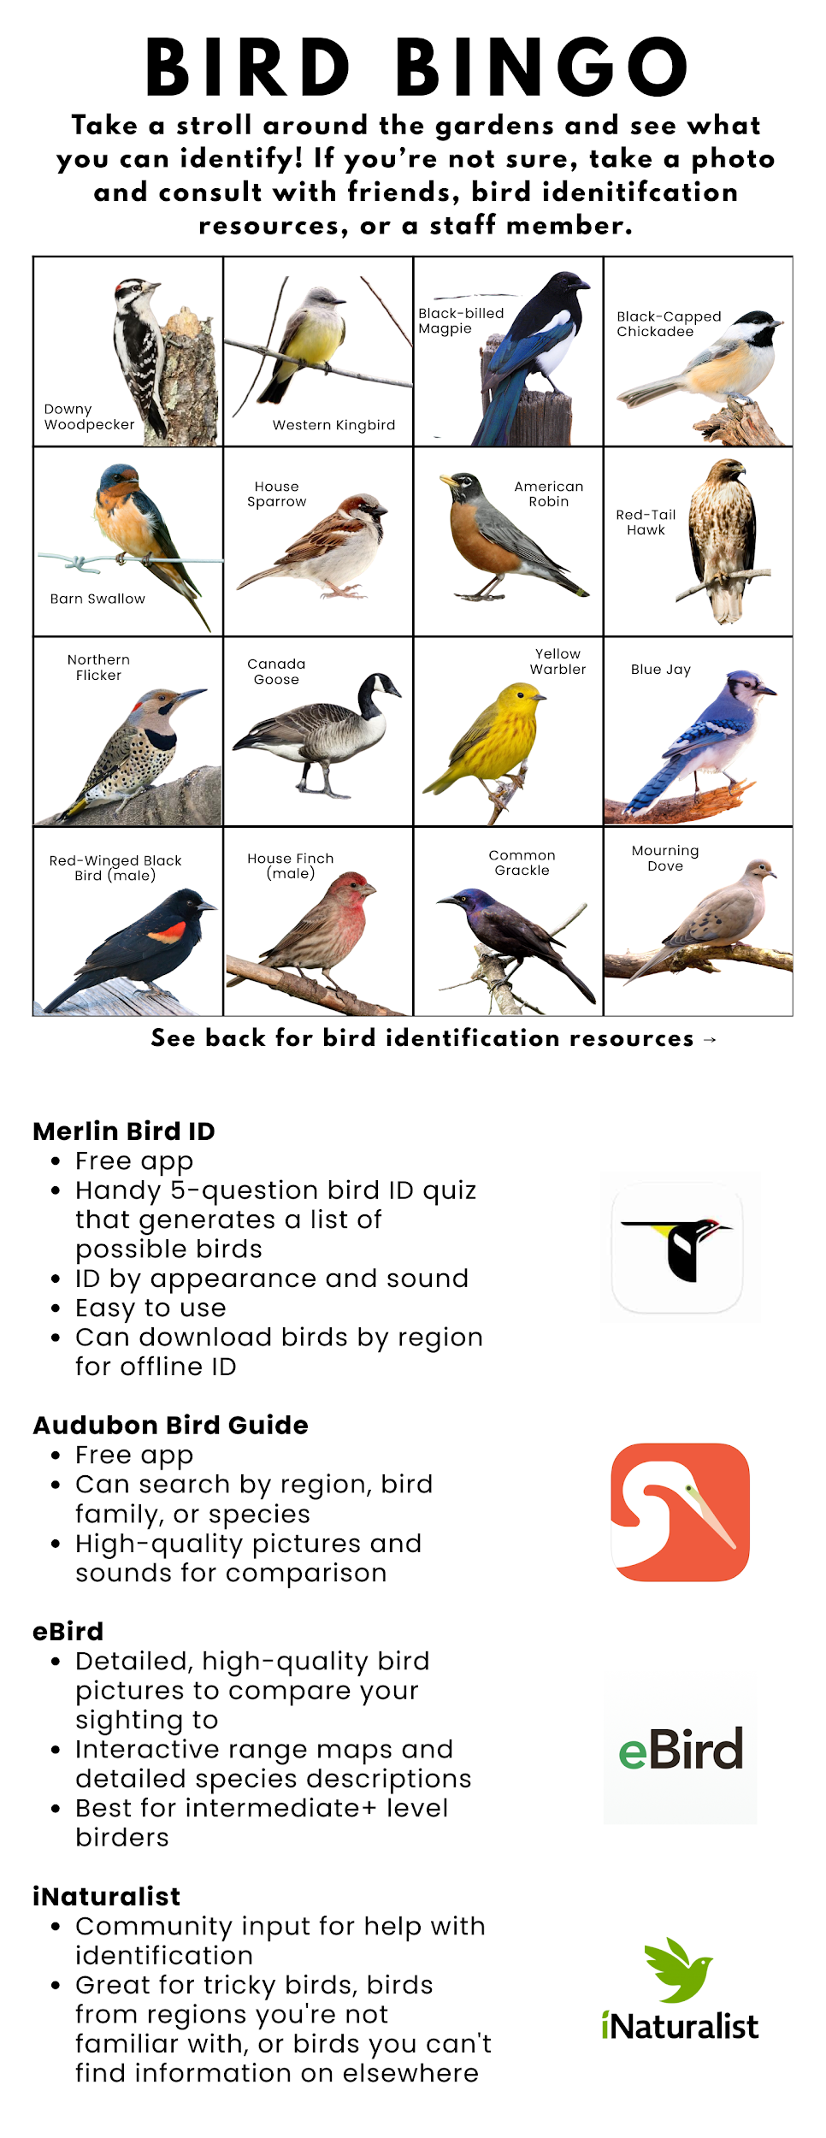



Best Practices

We incorporated several best practices into our event, particularly in the handout’s content. Firstly, we made our message personal through affective recall. Emotionally derived knowledge is more memorable than logically derived knowledge, so we made an effort to draw connections between the issues birds face and experiences our audience may have had to help them connect to and remember these issues. For example, in the section on the dangers of windows to birds, we asked if the reader had ever walked into a glass or mesh door without realizing it was closed, an experience many people have had, to help them connect birds' struggles with transparent materials to their own. Similarly, in the section regarding dark migration corridors, we explain that city lights can be confusing to birds as they try to navigate at night. This idea is less intuitive or widely discussed than birds' difficulty with windows, so to explain the issue and help readers remember, we compared the issue to the extremely common experience of being blinded by LED high-beam headlights on the road. Finally, in the section on keeping cats indoors, we explained that cats are naturally inclined to attack birds, a concept many cat owners have difficulty believing about *their* cat, so to help get the idea across, we asked the reader to think about cats’ reaction to their feathered toys. All of these examples connect birds’ struggles and conservation to experiences our audience can personally relate to. By making these connections, and in some cases, incorporating humor, we are able to connect our readers to the content, making them more likely to retain it. Additionally, by making our audience answer questions, think about experiences in their own lives, and draw connections, we are engaging them in active, participatory learning, allowing our content to be processed through the central route rather than passively and further increasing the chances that our audience will actually learn and retain our information.

We also used the best practice of framing our message to appeal to the values of our audience with the moral foundations theory. We predict that the audience this event attracts will be fairly liberal due to the basis of the event in environmental conservation, and the progressive, inclusive nature of Spring Creek Gardens’ mission and programming. Due to this, we framed our message to appeal to liberal values, as defined by the moral foundations theory, mainly focusing on preventing harm/promoting care (Dahl, 2025). To appeal to these values, we used language catered to liberal perspectives. For example, the word “protect” is used several times throughout the handout, particularly in the section on keeping cats indoors. Additionally, in the rodenticide section, the word “save” is used, which is a word that appeals to liberal values on its own, but also works to imply that the animals being discussed are victims in need of assistance, further appealing to preventing harm/promoting care values. We also use the word “preserve” in the dark migration corridors section, leaning on the preventing harm value. Additionally, the entire foundation of our event is to educate people about bird conservation, encouraging care for birds and the reduction of unintentional harm done to them, which is in alignment with liberal values. By presenting our message in this liberal framing, we are able to connect our issue to things our audience already cares about, helping them make connections to bird conservation and hopefully be inspired to participate in it. 66

A third best practice we implemented was leveraging cognitive biases, specifically, the status quo bias. On our handout, when asking participants to implement these bird conservation techniques, we were careful to avoid framing this as “new” behavior. Instead, we asked participants to “continue” their commitment to bird conservation by implementing some of the conservation techniques we described. This appeals to status quo bias, which encourages people to continue what they are already doing instead of changing their pattern, by presenting our desired behavior change as the given course of action, which they would be inclined to follow. This way, people are more likely to follow through on implementing bird conservation because it seems like the path of least resistance, giving it a perceived sense of convenience and familiarity.

Social Media Post

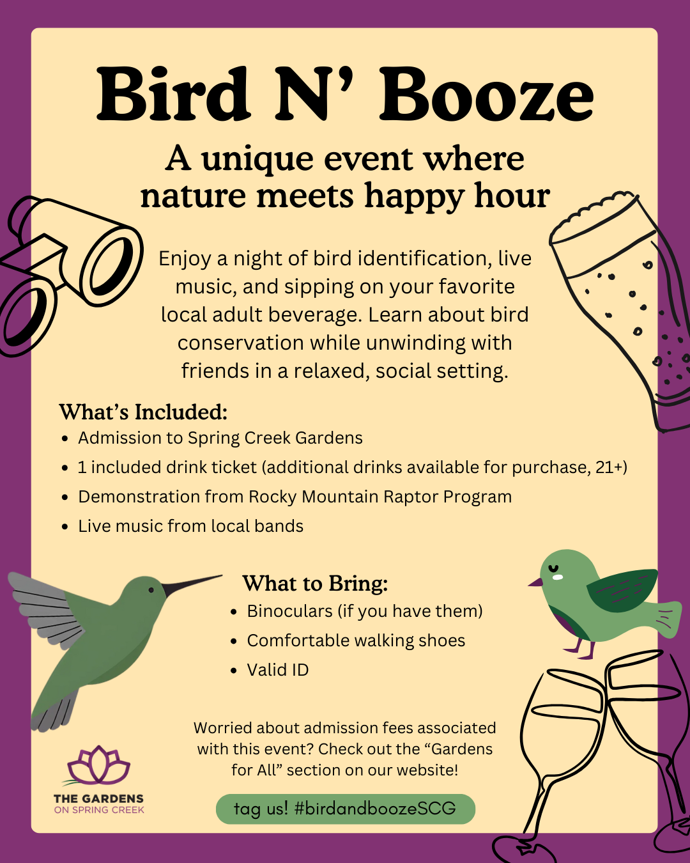

Join us on June 8th for our very first Bird N’ Booze event at the gardens! We will be playing bird ID bingo, learning about bird conservation, and sippin’ on our favorite local brews 🍻To celebrate our first ever Bird N’ Booze, we will be hosting a silent auction during the event and @localbandname will be joining us! You won’t want to miss it 😉

What to bring:

* Binoculars, if you have them
* A valid ID
* Comfortable walking shoes
* A friend or two to bird with!

We will see you there! 🐦

#birdandboozeSCG #birdingforeveryone #fortcollins #nature

This social media post is intended for Spring Creek Gardens’ Instagram account to alert their current followers of this upcoming event. Instagram was our platform of choice due to already having over 6,000 followers. This post informs potential participants of what they can expect to occur during the event, including which local stakeholders will be in attendance. Additionally, logistical and monetary considerations such as admissions pricing, event date, and event location are all communicated through this “virtual flyer”. Through our hashtag #birdandboozeSCG shared on our social media post and conservation handout, we intentionally implement a strategy of social diffusion. This hashtag leverages social diffusion by allowing content to circulate beyond Spring Creek Gardens’ existing followers and into new audiences by making posts discoverable to broader audiences who may be searching, following, or engaging with related topics. As a result, the hashtag increases overall visibility and awareness of the event, with the goal of driving higher levels of online engagement and, ultimately, increased participation in the event itself. Participants will be actively encouraged to use #birdandboozeSCG not only when sharing photos, videos, and reflections from the event, but also when posting about conservation practices they adopt afterward. In this way, the hashtag extends the impact of the event beyond a single moment in time and reinforces key conservation messages from the event. Additionally, the hashtag functions as a centralized “content hub” that aggregates all community-generated posts related to the event. When users click on the hashtag they see all event-related content, including participant experiences, conservation actions, and ongoing discussions can see all posts relating to #birdandboozeSCG. This content hub is critical for tracking engagement and assessing the effectiveness of our outreach efforts, making it an essential component of our evaluation strategy (see Evaluation section).

JEDIA+

One JEDI connection was to incorporate Spring Creek Gardens’ economic accessibility programs into our event pricing. We decided that, for our event, anyone qualifying for any of Spring Creek Gardens’ economic accessibility programs (SNAP benefits, library rental passes, community partnerships, ability discounts, or Indigenous descent) could receive discounted or free tickets as applicable. In addition to simply offering economic accessibility programs, it was important to us to advertise these programs because qualifying individuals may not be aware of them and end up missing out due to avoidable affordability concerns. To advertise these programs, our promotional social media post mentions such initiatives and invites the reader to visit the Gardens’ “Gardens for All” page to see if they could qualify for discounted admission. Promoting the Gardens for All programs for this event will have a dual JEDI effect, increasing both the economic accessibility of our program and also potentially the economic accessibility of the Gardens in general by educating the public on the programs available to them outside of the scope of our event.

Another JEDI connection we plan to implement would be having birding gear available on site to lend to participants during bird bingo. Birding is easier and more fun with proper equipment, particularly binoculars, but this gear can be very expensive. Having a few sets of binoculars to lend out on site could make the bird bingo portion of the event more accessible to new birders, those of lower socioeconomic status, or any others who did not have their own birding gear, allowing them to have an equally exciting and engaging experience as those who did have their own gear. This would lower the barriers for different people to participate fully in our event and could help people who otherwise would not have had access to such materials discover a passion for birding and or connect to conservation more personally. Ideally, our materials would be available in a Spanish translation to make our event and conservation information accessible across language barriers. Unfortunately, none of our group members are fluent in Spanish, and we know online translation services can create clunky, imprecise translations. Although we did not have the resources to get our handout professionally translated, if this project were to move forward, we would strongly encourage Spring Creek Gardens to translate the material to Spanish and any other languages common among their visitor base to make the material accessible to as many people as possible.

One area of JEDI where it is important to note this event may fall short is the fact that there is alcohol involved. Having alcohol available at the event is a strategy we developed to draw in our target audience of young to middle-aged Fort Collins residents to the Gardens. We still believe that this is an important audience to target as it seems to be a group the Gardens currently have less engagement from. Since we have the potential to significantly increase visitors in this age demographic, the tactic of offering alcohol at the event will help to draw them in. However, we also recognise that the presence of alcohol will pose a barrier to other groups potentially wishing to participate in this event. For one, with alcohol, this will be a 21+ event, excluding younger patrons and creating barriers for parents or caretakers who may want to participate but could struggle to find childcare. The presence of alcohol may also make this event inaccessible to people suffering from substance abuse and those in recovery or remission from such conditions. We do have some preliminary ideas regarding how these issues could be addressed, including offering discounted tickets to attend only the ambassador animal presentation and conservation handout portion of the event, which would be in an alcohol free zone in the gardens. We could also keep bird bingo sheets and conservation handouts printed at the front desk, so those who did not or could not attend the event for any reason could still have access to the conservation and identification resources we designed. If there were more time for this project to move forward, we would likely explore solutions to these issues in depth to ensure we were creating equitable, accessible programming in line with the Gardens’ mission.

Stakeholder Engagement

Several local businesses and organizations may be willing to contribute to this event. Our primary stakeholder for this event is the Rocky Mountain Raptor Program (RMRP). Their participation is essential to our event, as we have planned an allotted time for them to bring an ambassador bird and perform a demonstration. According to week 14 lecture content, participatory methods should fit the context, objectives, and stakeholders (Dahl, 2025). Our collaboration with RMRP would fit all three of these requirements indicating a strategic partnership. With both RMRP and our Bird and Booze event centering around bird conservation, our collaboration is contextually sound. Additionally, both parties share a similar objective. RMRP’s mission is to “inspire the protection and conservation of raptors and the environment through excellence in rehabilitation, education, and research” (*About the Rocky Mountain Raptor Program)*. This aligns with the event’s purpose of encouraging bird conservation by increasing community knowledge of threats facing birds. Another stakeholder who may be interested in collaborating with us on this event is Northern Colorado (NOCO) Bird Alliance. NOCO Bird Alliance strives to promote the appreciation, conservation and restoration of ecosystems, focusing on birds and other wildlife, through education, participation, stewardship, and advocacy. One idea for their involvement is to have them lead bird bingo, walking around the gardens with guests and assisting with bird identification. Another way this group could get involved is by organizing the silent auction that will be running during the event. The best way to decide how the organization would become involved would be through meeting with their leadership and collaboratively deciding together. Additionally, Wild Birds Unlimited is a bird seed and bird house store with several locations in Northern Colorado. As a stakeholder, they could donate products to the silent auction, such as a feeder, bird identification books, or bird seed. We will also provide our participants with at-home conservation handouts at the end of the event. This is another area where Wild Birds Unlimited may be able to enhance our product by providing bird window stickers or coupons that we could include in the handout, sending our guests house with a bird conservation goodie bag.

Additional stakeholders that we would invite to contribute to this event are Odell Brewing Company or New Belgium Brewing Company. With Spring Creek Gardens being licensed to serve alcohol, this partnership would allow for profits from alcohol sales to go to local businesses. Breweries are a prominent part of Fort Collins’ culture, and featuring their beverages at the event would enhance its local character and community appeal. Odell Brewing Company has specifically stated on their website that they are dedicated to supporting their community, and are committed to the preservation of the natural environment. Additionally, New Belgium states that part of their purpose is to inspire social and environmental change. Therefore, either breweries will contextually align with our event as they serve alcohol, and have objectives similar to ours. Additionally, incorporating a local brewery into our event allows us to outsource a skill that we ourselves do not already have. These companies have the appropriate inventory, point of sale technology, and materials needed to sell at an event. For example, Odell has an application form on their website to request on-site event appearances. This skillset is not one that we already have in our NR400 project group or at Spring Creek Gardens, further justifying why this partnership is not only strategic, but essential to the quality of the event.

Evaluation

The measurable outcome of our project would be the percentage of participating households that began implementing one at-home bird conservation technique after attending our event. This will be measured in two ways. First, an exit survey will be administered as our event concludes, asking attendees questions relating to the event’s structure and how we could improve the event for next time, and how likely they are to implement one of these bird conservation techniques at home. This strategy has the benefit of a potentially high response rate, as people will be asked to fill out the survey as our event concludes, an ideal time since participants may feel motivated to respond in the moment. However, this strategy would technically measure people's stated intent to implement a technique rather than their actual implementation, which is likely to make our program appear more successful than it is due to the attitude-behavior gap. To close this gap, we can send a follow-up survey by email or text message two weeks later to learn if the participant’s attitude upon the conclusion of the event translated into a behavior change.

Our second measurement technique is to include a hashtag on the conservation strategy handout and social media post, #birdandboozeSCG. This hashtag will encourage participants to share photos of the event and any bird-friendly changes they made since attending. This strategy would measure actual implementation, attendance, and allow us insight into how engaged our participants were during the event. We predict that this strategy may have a lower participation rate than our surveys. Using a social media hashtag restricts respondents to those who have a social media account, which may artificially make our program look less effective and be less inclusive of all participants. Ideally, both of these measurement tactics will be employed and their results compared, allowing Spring Creek Gardens to collect more outcome data and potentially measure the severity of the attitude-behavior gap among participants.

Tools and Permissions

Spring Creek Gardens has our group’s permission to use this event idea and attached products for real-world implementation. If chosen for implementation, the Bird Bingo card may need to be reviewed to ensure that all bird photography used for identification is either available for free use, or credits the photographer. Canva was used to create Bird Bingo, our Conservation Strategy handout, and the social media post. Google Docs was used to write our report, and Google Drive was used for collaborative file management.

References

*About the Rocky Mountain Raptor Program – Rocky Mountain Raptor Program*. https://www.rmrp.org/about/. Accessed 15 Dec. 2025.

Benoit, Cara Lockwood. “Why You Should Start Burying Pennies In Your Yard Or Garden.” *Garden Guides*, 24 Aug. 2025, https://www.gardenguides.com/1941296/why-bury-pennies-lawn-grass/.

*Bird-Friendly Home Toolkit | U.S. Fish & Wildlife Service*. https://www.fws.gov/library/collections/bird-friendly-home-toolkit. Accessed 14 Dec. 2025.

Dahl, Jamie (2025). NR 400 Recitation- week 4. Powerpoint slides. NR 400, Public Communication in Natural Resources. https://colostate.instructure.com/courses/210569/files/36999765?module_item_id=7345157

Dahl, Jamie (2025). NR 400 Recitation- week 14. Powerpoint slides. NR 400, Public Communication in Natural Resources. https://colostate.instructure.com/courses/210569/files/38085256?module_item_id=7452720.

*How Bird-Friendly Are Your Holiday Decorations? | Audubon*. 4 Dec. 2020, https://www.audubon.org/news/how-bird-friendly-are-your-holiday-decorations.

*How to Have a Bird-Friendly Halloween | Audubon*. 18 Oct. 2024, https://www.audubon.org/magazine/how-have-bird-friendly-halloween.

Jones, Sorrel, et al. “Audience Segmentation to Improve Targeting of Conservation Interventions for Hunters.” *Conservation Biology*, vol. 33, no. 4, 2019, pp. 895–905. *JSTOR*, https://www.jstor.org/stable/48553781. Accessed 16 Oct. 2025.

*Lock Up Your Cats! Do It For The Birds | Audubon*. 17 Dec. 2010, https://www.audubon.org/news/lock-your-cats-do-it-birds.

*National Public Health Information Coalition (NPHIC) - Millennials and Gen Zers Embrace “Life Can Take You Higher than Alcohol.”* https://www.nphic.org/blog/738-millennials-and-gen-zers-embrace-life-can-take-you-higher-than-alcohol. Accessed 15 Dec. 2025.

*Poisons Used to Kill Rodents Have Safer Alternatives | Audubon*. 15 Jan. 2013, https://www.audubon.org/magazine/poisons-used-kill-rodents-have-safer-alternatives.

Swaddle JP, Brewster B, Schuyler M, Su A. 2023. Window films increase avoidance of collisions by birds but only when applied to external compared with internal surfaces of windows. *PeerJ* 11:e14676 https://doi.org/10.7717/peerj.14676.

*The Deloitte Global 2022 Gen Z and Millennial Survey | Deloitte Global*. https://www.deloitte.com/global/en/issues/work/genzmillennialsurvey-2022.html. Accessed 15 Dec. 2025.